KCA UNIVERSITY
SCHOOL OF TECHNOLOGY
BACHELOR OF INFORMATION TECHNOLOGY
IMPLEMENTATION PLAN
CozyStay
Phased delivery, verification, and release plan
PREPARED BY
Zubeda Obwoge
Registration Number: 25/09770
Bachelor of Information Technology (BIT)
26 October 2026
Submitted for approval

Document information and approval
Field | Details
Document title | CozyStay Implementation Plan
Version / date | Version 1.1 / 26 October 2026
Status | Submitted for approval; not an authorization for production release
Prepared by | Zubeda Obwoge, Registration Number 25/09770
Source baseline | CozyStay SRS v1.1 (16 October 2026), SDS v1.0, repository architecture and deployment documentation, as identified in the source plan
Purpose of revision | Clarify execution, dependencies, traceability, quality gates, risks, and acceptance evidence without treating unresolved/proposal features as approved scope.

Approval record
Approver | Name | Decision | Signature | Date
Academic supervisor | Isaac Okola | Approve / Approve with changes / Revise | ________________ | ____________

Approval condition: any “Approve with changes” decision must list the required changes, owner, and due date in the decision log before the baseline is treated as approved.

Contents
Document information and approval 2
Approval record 2
Contents 2
1. Executive summary and objectives 3
1.1 Objectives 3
1.2 Measures of progress 3
2. Scope, priorities, and exclusions 4
2.1 Minimum release scope 4
2.2 Conditional or deferred scope 4
2.3 Scope change rule 4
3. Architecture and implementation controls 4
3.1 Non-negotiable business controls 5
4. Delivery schedule and work packages 5
4.1 Milestone review format 6
5. Requirements traceability and deliverables 6
5.1 Required project artefacts 7
6. Roles, responsibilities, and governance 7
6.1 Coordination cadence 8
7. Quality assurance and test strategy 8
7.1 Defect severity and release rule 8
8. Change, configuration, deployment, and rollback 9
8.1 Change control 9
8.2 Environment and deployment controls 9
8.3 Release checklist 9
8.4 Rollback and recovery 9
9. Risk register 9
10. Definition of done and release acceptance 10
10.1 Definition of done for an individual requirement 10
10.2 Minimum release acceptance scenarios 10
10.3 Release decision 11
11. Open decisions and approval checklist 11
11.1 Baseline approval checklist 12
Appendix A. Working templates 12
A1. Decision-log entry 12
A2. Test-evidence entry 12
A3. Phase-gate sign-off 12

List of Figures
Figure 1. System architecture and authoritative data flow
Figure 2. Indicative eight-week implementation roadmap
Figure 3. Verification, phase gates, and release decision workflow

1. Executive summary and objectives
This plan defines a controlled, eight-week indicative sequence for implementing CozyStay. It establishes work packages, dependencies, accountable roles, deliverables, verification evidence, and decision gates. Dates and effort remain estimates until the supervisor/project owner confirms capacity and milestone dates.
Target outcome: a connected customer portal, central REST API and MySQL data store, Electron/React admin client, and Windows C#/.NET WPF point-of-sale (POS) workflow. The core end-to-end path is property discovery → booking request → server-confirmed payment outcome → receipt → staff reconciliation.

1.1 Objectives
- Deliver the Must requirements first and make each delivered requirement traceable to implementation and test evidence.
- Maintain one authoritative source for shared booking and payment facts.
- Enforce role, ownership, availability, pricing, and state-transition rules at the server/API boundary.
- Provide reliable receipt, cashier-shift, and reconciliation workflows for approved payment methods.
- Limit offline writes to explicitly approved operations and prevent duplicate booking or financial records during retries.
- Release only after documented functional, security, recovery, and stakeholder acceptance checks pass.

1.2 Measures of progress
Measure | Evidence / completion rule
Requirement coverage | Every approved Must requirement is mapped to a phase, implementation location, and test case; unresolved mappings are recorded.
Build and setup repeatability | A clean environment can install dependencies, apply migrations, seed synthetic test data, and start the web/API/database stack using documented steps.
Booking integrity | Automated/manual tests show invalid dates and overlapping reservations are rejected safely, including concurrent attempts.
Payment integrity | Only server-verified outcomes are recorded as successful; duplicate provider callbacks/retries do not duplicate payment or receipt records.
Access control | Positive and negative tests demonstrate that each role can perform permitted actions only.
Offline safety | Supported queued actions survive restart/retry and do not silently overwrite booking/payment facts.
Release readiness | Required test evidence, deployment runbook, backup/restore evidence, defect disposition, and written acceptance are present.

2. Scope, priorities, and exclusions

2.1 Minimum release scope
Area | Baseline scope
Identity and access | Registration/login, sign-out, password handling/recovery, token lifetime, role checks, and ownership checks.
Property catalogue | Listing/detail/filtering/availability, published/inactive states, and administrator property CRUD.
Booking | Validated reservation flow, overlap-safe transaction, server-calculated price breakdown, source channel, arrival fields, explicit status transitions, and approved cancellation rules.
Payments and receipts | Configured provider initiation/callback verification, cash tender attribution, payment history, unique receipts, and auditable reconciliation.
Admin and POS | Booking search/actions, staff/customer administration as approved, walk-in flow, shift open/close, variance calculation, and role-restricted operations.
Trust and services | Review eligibility/moderation and approved arrival/service requests.
Operations | Reports defined by the approved specification, audit records, backup/restore, logs, deployment documentation, and bounded offline synchronization.

2.2 Conditional or deferred scope
The following are not considered committed production features until the relevant SRS decision is approved, implemented, and tested:
- Meal/restaurant posting and pickup workflow.
- External notifications and SMTP/provider-dependent messages.
- Refunds/voids beyond explicitly supported and tested provider/cash workflows.
- Deposit, tax, cancellation, service-pricing, and booking-expiry rules not yet approved.
- Printer-specific behavior until a target printer/driver is tested.
- Advanced automatic sync conflict resolution.
Mock screens, proposal features, local pending transactions, and sandbox payment success must not be described as production-complete or live-settlement-ready.

2.3 Scope change rule
A scope change must identify the affected SRS requirement ID(s), reason, priority, owner, schedule/cost impact, data migration impact, security impact, acceptance criteria, and approval decision. Unapproved changes stay outside the release baseline.

3. Architecture and implementation controls
Component | Baseline technology / responsibility | Key control
Customer web UI | React + Vite; responsive pages call REST/JSON API. | No client-only authoritative booking/payment state.
Service/API | Node.js 18+ and Express modular monolith. | Validation, authorization, business rules, integration adapters, reporting endpoints, consistent errors and logs.
Central persistence | MySQL 8+; repository-owned schema and migrations. | System of record for shared accounts, properties, bookings, payments, receipts, shifts, reviews, services, and audit facts as approved.
Admin desktop | Electron + React; SQLite for local persistence/cache and supported offline queue. | Offline write allowlist; durable outbox; no silent last-write-wins for booking/payment facts.
POS desktop | Windows C#/.NET WPF; SQLite for POS-local workflow. | Cashier controls, shift lifecycle, walk-in flow, receipt output dependent on tested device.
Shared contracts | Shared TypeScript types/constants/schemas where supported. | Keep API/client contracts consistent and version changes.
Deployment | Docker Compose for web/API/MySQL; native installation for desktop clients. | Environment-specific configuration; no secrets in source control; persistent DB volume and tested recovery.

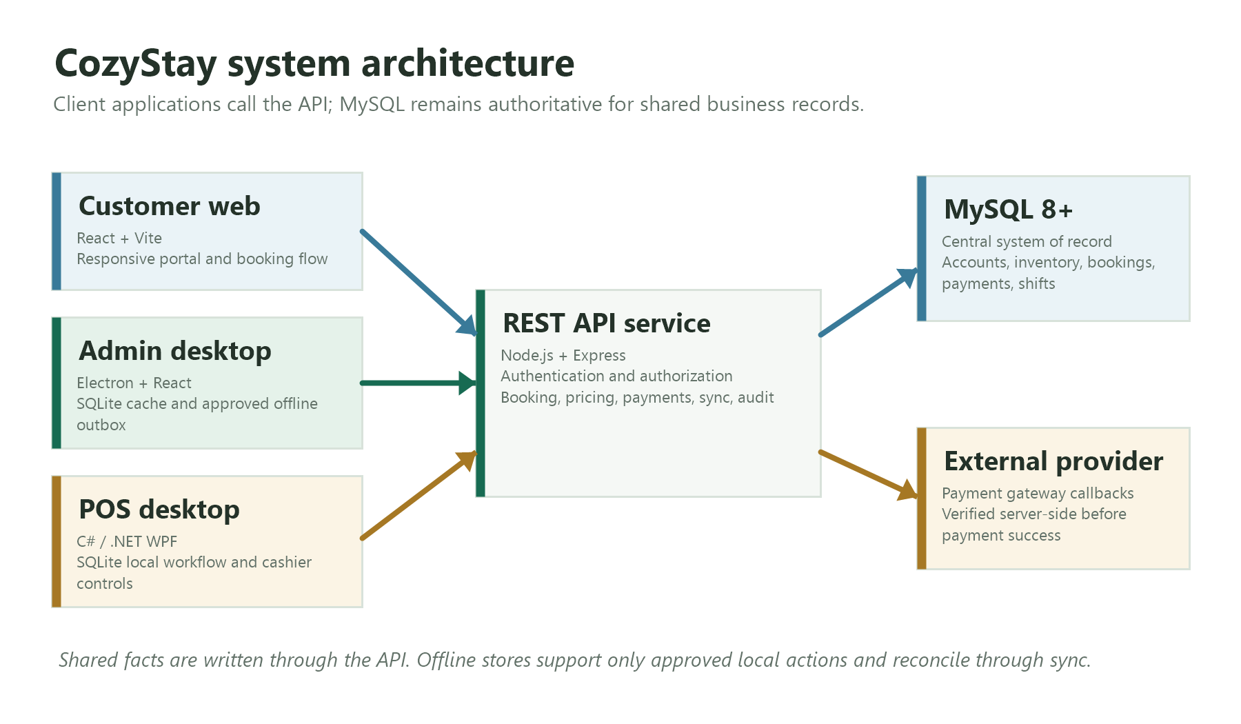
1. System architecture and authoritative data flow

3.1 Non-negotiable business controls
- Authorization and ownership are enforced server-side on every protected endpoint, not only by hiding UI controls.
- Availability and booking overlap checks execute within a transaction or equivalent safe concurrency control.
- Prices and money totals are calculated and validated server-side using decimal-safe representations; currency is KES unless the approved baseline states otherwise.
- Payment success is based on verified provider/server evidence and amount/currency matching, not on a client redirect or locally queued status.
- State transitions are explicit and auditable; invalid transitions are rejected.
- Idempotency keys/stable transaction identifiers protect retries and callback processing.
- Production personal/payment data is not used as seed data or committed to the repository.

4. Delivery schedule and work packages
The schedule below is indicative. Weeks can overlap only where dependencies permit. Each phase ends with a review gate; failed gates require a corrective action owner and revised target before dependent work is accepted.
Phase / timing | Activities | Deliverables and evidence | Dependency / exit gate
0. Baseline and decisions  Week 1 | Review SRS/SDS and repository; confirm Must scope, role matrix, booking states, cancellation/deposit/tax rounding, payment methods, service catalogue, time zone, retention, reports, printer, sync rules, team capacity. | Approved scope baseline; decision log D-01–D-09; backlog; requirement-to-code/test map; synthetic-data plan; environment checklist. | Gate: supervisor/owner confirms minimum release scope. Unknown rules are deferred explicitly.
1. Foundation and data integrity  Weeks 1–2 | Stabilize environment/configuration, migrations, API response/error conventions, logging/correlation, Docker startup, entity keys/constraints/indexes, money/time fields, persistent volume and recovery. | Repeatable setup guide; migrations; health endpoint; core schema; role definitions; synthetic fixtures; backup/restore test record. | Depends on Phase 0 decisions. Gate: clean setup and migrations succeed.
2. Identity, catalogue, booking  Weeks 2–4 | Implement authentication and password handling; role/ownership checks; property listing/filtering/availability/admin CRUD; transactional booking, server price breakdown, status transitions, cancellation constraints; connect web/admin to central API. | End-to-end test evidence from search to pending reservation and staff review; API tests; role-negative tests; concurrency tests. | Depends on stable schema/API. Gate: invalid and concurrent conflicting reservations are rejected without corruption.
3. Payments, receipts, finance  Weeks 4–5 | Integrate configured payment sandbox; verify callbacks/signatures where supported; idempotent reconciliation; match amount/currency; cash tender attribution; unique receipts; payment history; approved deposit/balance/refund policy. | Sandbox evidence; cash-path evidence; receipt retrieval across clients; reconciliation report/test. | Depends on booking states and provider credentials. Gate: no client-only paid status; duplicate callbacks do not duplicate payment/receipt.
4. Admin and POS workflows  Weeks 5–6 | Complete approved booking actions, staff/customer management, guest service queue, review moderation, housekeeping/maintenance view, settings/branding, audit/report views; POS walk-in, history, receipt, shifts and variance. | Role-tested admin/POS scenarios; printer test record; shift close/reconciliation evidence. | Depends on booking/payment APIs. Gate: cashier cannot perform admin-only actions; totals reconcile.
5. Offline sync, services, trust  Weeks 6–7 | Define offline allowlist; implement stable IDs, durable outbox, retries/backoff, idempotent application, server mapping and visible conflicts; review eligibility/moderation; approved arrival/service requests. | Network interruption/restart replay evidence; conflict-resolution guide; review/service state tests. | Depends on stable APIs and business states. Gate: retries/restarts create no duplicate booking/payment records.
6. Hardening, acceptance, release  Weeks 7–8 | Run functional/security/concurrency/payment/POS/sync/accessibility/browser/performance/recovery checks; fix blocker/high defects; regression; prepare TLS, secrets, backup, monitoring, runbook and rollback package. | Test summary; defect register; release notes; deployment guide; restore rehearsal; support handoff; written acceptance. | Depends on all Must workflows. Gate: owner/supervisor approves acceptance and residual risks.

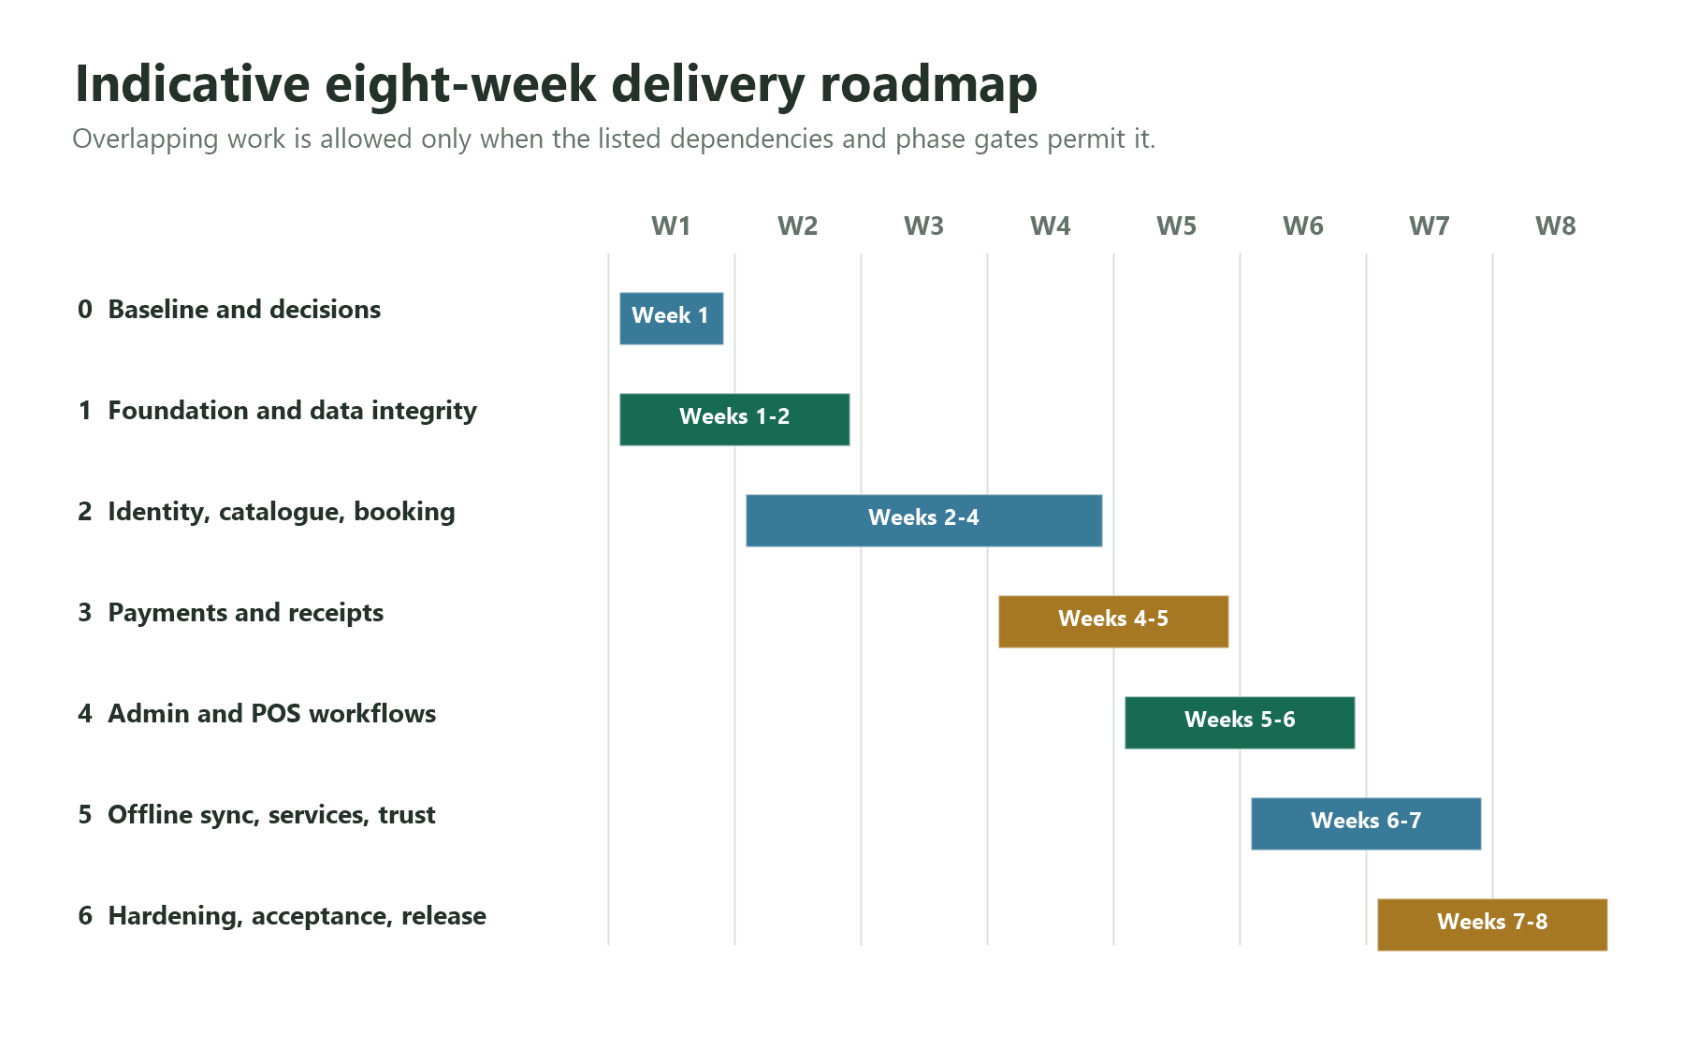
2. Indicative eight-week implementation roadmap

4.1 Milestone review format
- What was planned versus completed, with requirement IDs and evidence links.
- Open defects and risks, severity, owner, mitigation, and target date.
- Decisions needed and who is authorized to decide them.
- Dependencies and scope/schedule impacts.
- Gate decision: pass, pass with recorded conditions, or fail and rework.

5. Requirements traceability and deliverables
The source plan references SRS Must requirements and acceptance tests AT-01..AT-10 but does not reproduce their exact wording. Populate the matrix below from the approved SRS and Test Plan; do not invent requirement IDs or mark coverage complete until evidence exists.
SRS ID / priority | Requirement summary (copy from approved SRS) | Phase / component | Test case ID | Evidence location | Status / owner
Must / ID: ______ | Exact approved requirement text | Phase: ____ / Component: ____ | TC: ____ | Link/path: ____ | Not started / In progress / Pass / Deferred; owner: ____
Must / ID: ______ | Exact approved requirement text | Phase: ____ / Component: ____ | TC: ____ | Link/path: ____ | Not started / In progress / Pass / Deferred; owner: ____
Should / ID: ______ | Exact approved requirement text | Phase: ____ / Component: ____ | TC: ____ | Link/path: ____ | Not started / In progress / Pass / Deferred; owner: ____
AT-01 to AT-10 | Use exact scenario and expected result from Test Plan | Relevant phase/component | AT-__ | Run result / screenshot / log | Pass / Fail / Blocked; owner: ____

5.1 Required project artefacts
Artefact | Minimum content | Owner / review point
Decision log | D-01–D-09, decision, options considered, approver, date, impact, status. | Developer maintains; supervisor/owner approves policy decisions.
Backlog and traceability matrix | Requirement ID, priority, acceptance condition, phase, implementation reference, test case, status, defect link. | Developer; reviewed weekly.
Database and API documentation | ERD/schema, migration history, endpoint contracts, error conventions, auth requirements. | Developer; review during Phases 1–3.
Test evidence pack | Test case, environment/build, test data, steps, expected/actual result, pass/fail, defect reference, date. | Developer; reviewed at phase gates.
Operations pack | Deployment steps, environment variables template, backup/restore procedure, monitoring/logging, operator runbook, rollback. | Developer; release gate.
User guidance | Customer journey, admin workflows, cashier shift/receipt flow, known limitations and offline behavior. | Developer with admin/cashier review.

6. Roles, responsibilities, and governance
Work / decision | Student / developer | Supervisor / project owner | Admin / operations rep | Cashier / reception rep | External provider / device owner
Scope and policy decisions | Prepare options; record impact | A/R | C | C | C where relevant
Implementation and migrations | A/R | I | C | C | C
Admin workflow validation | R | A | R | C | I
POS, shift, receipt validation | R | A | C | R | C
Provider/printer setup | R for integration | A for acceptance | I | C | R
Test evidence and defect fixes | A/R | C / gate approval | C | C | C
Release acceptance | Prepare evidence | A/R | C | C | C

Legend: A = accountable for the decision/outcome; R = responsible for doing the work; C = consulted; I = informed. Confirm names and availability at baseline approval.

6.1 Coordination cadence
- Hold one weekly review covering progress, next dependencies, defects, risks, and decisions.
- Keep work items and defects in one agreed tracker; assign one owner and target date to each action.
- Record approval decisions in the decision log or version control; verbal approval alone is not release evidence.
- Escalate a blocked Must requirement, security issue, data-integrity issue, or provider dependency at the next review or immediately if it threatens data or release safety.

7. Quality assurance and test strategy
Test level / area | Required checks | Exit evidence
Unit / component | Validation, price calculation, state transitions, idempotency helpers, permission rules, and error handling. | Automated test results and code/test references.
API / integration | Authentication, ownership, booking transaction, MySQL persistence, provider adapter/callback verification, receipt retrieval, report totals. | API test results and sanitized logs.
Booking integrity | Invalid dates, unavailable property, overlapping stays, concurrent booking attempts, cancellation/expiry rules once approved. | Tests demonstrate rejection or correct transition without duplicate/overlapping confirmed records.
Payment / finance | Pending/success/failure paths, invalid callback, amount/currency mismatch, duplicate callback, timeout/retry, cash attribution, receipt uniqueness. | Sandbox and cash-path evidence; totals reconcile.
Role / security | Unauthorized endpoint access, role escalation, cross-user/property access, expired/invalid token, secret/config scan. | Negative access test results; no unresolved critical/high security defects.
POS / device | Walk-in booking, shift open/close, expected/count/variance, receipt print failure/reprint, cashier restrictions. | Test record on the selected target printer/driver or documented fallback.
Offline / resilience | Queue persistence across restart, retry/backoff, duplicate replay, server mapping, conflict visibility, loss/recovery of connectivity. | Replay and conflict evidence; no silent overwrite of booking/payment facts.
Usability / compatibility | Responsive customer views, accessibility basics, supported browser/workstation baseline, loading/error/pending/offline messaging. | Checklist and defect disposition.
Deployment / recovery | Clean deployment, TLS/configuration, persistent volume, backup restore to a fresh environment, logs/health checks, rollback rehearsal. | Deployment checklist, restore record, rollback notes.

7.1 Defect severity and release rule
Severity | Definition | Release treatment
Critical | Data loss/corruption, unauthorized access, financial integrity failure, or core system unavailable. | Must be fixed and retested; release blocked.
High | Major Must workflow fails or a serious security/operational issue has no safe workaround. | Must be fixed and retested; release blocked unless formally reclassified with evidence and approval.
Medium | Partial failure with a viable documented workaround; no material data/security risk. | May be accepted only with owner, workaround, target fix, and written approval.
Low | Minor cosmetic/usability issue with no meaningful functional impact. | Record and schedule; disclose if relevant.

A test is not “passed” merely because a screen renders. It must demonstrate the expected behavior, including failure and recovery cases where applicable.
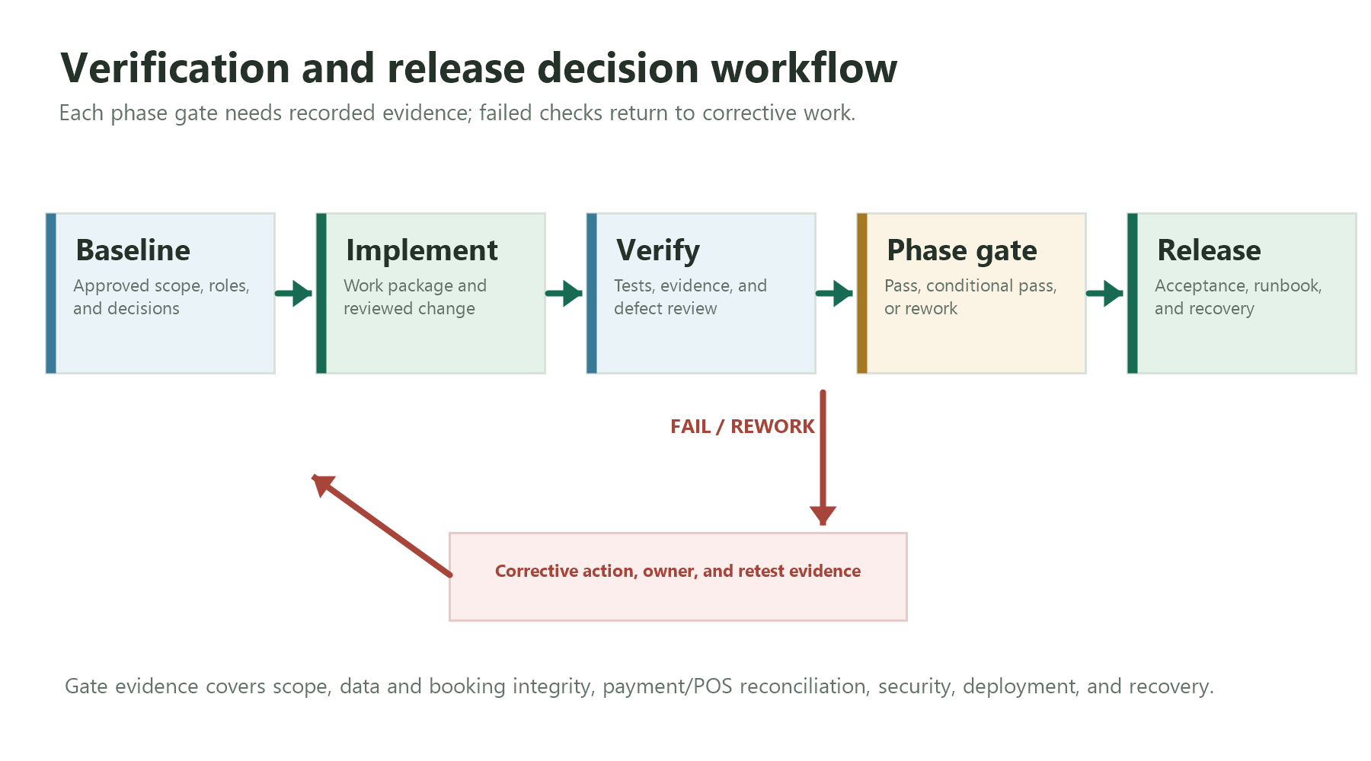
3. Verification, phase gates, and release decision workflow

8. Change, configuration, deployment, and rollback

8.1 Change control
- Create a change record linked to SRS requirement ID(s), rationale, owner, acceptance condition, code/test impact, migration impact, security/privacy impact, and schedule effect.
- Review changes through branches and reviewed commits; pin dependency versions and keep configuration templates separate from secrets.
- Review migrations for compatibility and data impact. Take a verified backup before production schema changes.
- Update requirement traceability, test cases, API/schema documentation, and release notes with each accepted change.

8.2 Environment and deployment controls
- Keep development, test/sandbox, and production configuration separate. Use synthetic data in development/test.
- Do not commit credentials, provider secrets, private keys, or real personal/payment data. Rotate any secret exposed during development.
- Deploy web/API/MySQL from a tagged, reproducible source version. Configure admin/POS clients with the intended API endpoint per workstation.
- Enable TLS for production endpoints; verify persistent database storage, access controls, backups, logs, health checks, and recovery instructions.
- Confirm provider callback URL/signature configuration and target printer/driver before claiming the corresponding feature is ready.

8.3 Release checklist
- ☐ Scope baseline and open decisions approved or explicitly deferred.
- ☐ All Must requirements and AT-01..AT-10 have recorded results from the approved Test Plan.
- ☐ No open critical/high defects; accepted medium/low defects have owner, workaround, and approval.
- ☐ Security/role-negative tests pass; secrets are protected/rotated; TLS and production configuration verified.
- ☐ Persistent database volume, backup, and restore have been tested; logs/monitoring and operator runbook are ready.
- ☐ POS/printer and payment provider claims match the actual tested configuration.
- ☐ Release notes, known limitations, support handoff, and rollback package are prepared.
- ☐ Project owner/supervisor has recorded acceptance.

8.4 Rollback and recovery
Rollback must restore a compatible application build while preserving valid data. Database rollback is not automatic: use a reviewed forward-fix or a tested restore procedure based on migration risk. Record the trigger, decision-maker, steps, data impact, verification, and follow-up actions for every rollback or recovery event.

9. Risk register
ID / risk | Likelihood / impact | Prevention / response | Owner / trigger
R1. Unconfirmed tax, deposit, cancellation, expiry, or service pricing rules | Medium / High | Obtain written owner decision before coding; use explicit configuration only after approval; defer unsupported behavior. | Project owner; trigger: policy unresolved at Phase 0 gate.
R2. Payment provider/callback setup delayed | Medium / High | Use sandbox adapter; test signature/verification and idempotency; separate sandbox evidence from live settlement claims. | Developer + provider owner; trigger: credentials/callback unavailable by Phase 3.
R3. Duplicate or conflicting offline writes | Medium / High | Restrict offline allowlist; stable IDs/durable outbox; idempotent server application; visible manual/domain-specific conflict resolution. | Developer; trigger: replay creates duplicate or ambiguous booking/payment.
R4. Role or ownership authorization gap | Medium / Critical | Central server checks on each endpoint; negative access tests; review privileged actions. | Developer; trigger: unauthorized action succeeds.
R5. Printer/driver variability | Medium / Medium | Select an actual device; test print failure and reprint path; document fallback. | Device owner + cashier rep; trigger: device not available by Phase 4.
R6. Data loss or failed recovery | Low–Medium / Critical | Persistent MySQL volume; separate protected backups; restore rehearsal in a fresh environment. | Developer/operations; trigger: restore fails or backup is unverified.
R7. Scope expansion or limited capacity | High / High | Must-first prioritization; estimate effort; defer Should/Could items; approve changes and revise dates. | Developer + supervisor; trigger: Must milestone slips.
R8. Privacy/retention rules unresolved | Medium / High | Agree what data is collected, who can access it, retention/deletion, backup retention, and test-data approach before production. | Project owner; trigger: data handling cannot be justified/documented.
R9. Concurrent booking race condition | Medium / High | Transactional availability checks, appropriate database constraints/locking strategy, concurrency tests. | Developer; trigger: parallel requests can reserve same inventory/dates.
R10. Weak deployment or undocumented operations | Medium / High | Reproducible deployment, environment checklist, health/logging, runbook, backup/restore and rollback rehearsal. | Developer; trigger: clean deployment/recovery cannot be repeated.

Risk review rule: reassess likelihood/impact weekly and at each phase gate. Any critical risk without a tested mitigation blocks release until the owner formally accepts a documented residual risk and the supervisor/project owner agrees.

10. Definition of done and release acceptance

10.1 Definition of done for an individual requirement
- Requirement wording and acceptance condition are agreed and linked to an SRS ID.
- Implementation is in the correct API/client boundary and reviewed; database/API changes are documented.
- Input validation, role/ownership checks, expected state transitions, error paths, audit needs, localization, and loading/pending/offline states are handled where relevant.
- Relevant automated and manual tests pass; regression evidence is recorded for fixes.
- No secrets or real personal/payment data are committed; logs do not expose sensitive credentials or payment data.
- User, API/schema, operations, and support documentation are updated as applicable.
- Reviewer/owner accepts the evidence or records the feature as deferred with residual risk and owner.

10.2 Minimum release acceptance scenarios
ID | Scenario / expected result | Evidence required
AT-01 | Use exact approved SRS Test Plan scenario and expected result. | Test run ID, build, result, evidence link.
AT-02 | Use exact approved SRS Test Plan scenario and expected result. | Test run ID, build, result, evidence link.
AT-03 | Use exact approved SRS Test Plan scenario and expected result. | Test run ID, build, result, evidence link.
AT-04 | Use exact approved SRS Test Plan scenario and expected result. | Test run ID, build, result, evidence link.
AT-05 | Use exact approved SRS Test Plan scenario and expected result. | Test run ID, build, result, evidence link.
AT-06 | Use exact approved SRS Test Plan scenario and expected result. | Test run ID, build, result, evidence link.
AT-07 | Use exact approved SRS Test Plan scenario and expected result. | Test run ID, build, result, evidence link.
AT-08 | Use exact approved SRS Test Plan scenario and expected result. | Test run ID, build, result, evidence link.
AT-09 | Use exact approved SRS Test Plan scenario and expected result. | Test run ID, build, result, evidence link.
AT-10 | Use exact approved SRS Test Plan scenario and expected result. | Test run ID, build, result, evidence link.

Important: the original implementation plan names AT-01..AT-10 but does not include their scenario text. Replace the placeholder wording above with the exact approved Test Plan wording before acceptance review.

10.3 Release decision
Decision | Conditions
Accept | All release gates pass; required Must/AT evidence is present; no critical/high open defects; residual risks and known limitations are documented; approver signs.
Accept with conditions | Only if permitted by supervisor/project owner; each condition has an owner, due date, workaround, and explicit written approval. Does not waive critical data/security/financial integrity failures.
Reject / rework | Any required gate fails, key evidence is missing, critical/high defect remains, recovery is unproven, or acceptance criteria are not met.

11. Open decisions and approval checklist
The source plan identifies SRS decisions D-01 through D-09. Resolve them with the appropriate stakeholder and record the decision, rationale, approver, date, and impacted requirements.
Decision | Question to resolve | Decision owner / status
D-01 | Who is the owner role and which administrative actions can it authorize? | Owner: ____ / Open
D-02 | What are the meal/restaurant catalogue, pickup workflow, and operational rules, if included? | Owner: ____ / Open / Defer
D-03 | Which payment provider(s) are configured? What are deposit, balance, refund, and void rules? | Owner: ____ / Open
D-04 | What are booking expiry, cancellation, and concurrency rules? | Owner: ____ / Open
D-05 | Which operations are allowed offline, and how are conflicts resolved? | Owner: ____ / Open
D-06 | Which printer/receipt format and reprint rules are required? | Owner: ____ / Open
D-07 | What privacy, data retention, deletion, backup protection, and access rules apply? | Owner: ____ / Open
D-08 | What are report definitions, business time zone, tax treatment, and rounding rules? | Owner: ____ / Open
D-09 | Where are the approved Must requirements and AT-01..AT-10 acceptance scenarios, and what evidence proves each? | Owner: ____ / Open

11.1 Baseline approval checklist
- ☐ SRS/SDS versions and repository baseline confirmed.
- ☐ Must requirements, role matrix, acceptance criteria, and AT-01..AT-10 scenario text available.
- ☐ D-01 through D-09 decisions approved or explicitly deferred with impact recorded.
- ☐ Eight-week schedule checked against team capacity, provider onboarding, hardware access, and supervisor milestones.
- ☐ Owners and reviewers named for each work package and acceptance gate.
- ☐ Test environment, synthetic data, repository workflow, issue tracker, and evidence storage agreed.
- ☐ Conditional scope and release limitations understood by stakeholders.

Appendix A. Working templates

A1. Decision-log entry
Field | Entry
Decision ID / date | D-__ / YYYY-MM-DD
Question and options | ____________________________________________
Decision and rationale | ____________________________________________
Approver | ____________________________________________
Affected requirements / components | ____________________________________________
Schedule / risk impact | ____________________________________________
Status | Open / Approved / Deferred / Superseded

A2. Test-evidence entry
Field | Entry
Requirement / test ID | ____________________________________________
Build / environment | ____________________________________________
Preconditions and synthetic test data | ____________________________________________
Steps and expected result | ____________________________________________
Actual result / Pass-Fail-Blocked | ____________________________________________
Evidence link / defect ID | ____________________________________________
Tester / date / reviewer | ____________________________________________

A3. Phase-gate sign-off
Gate | Decision | Conditions / defects | Approver and date
Phase __ / Week __ | Pass / Conditional pass / Fail | ________________________ | ________________________

